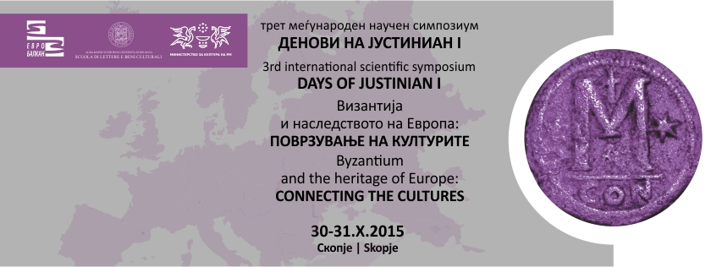
APPLICATION FORM

3rd INTERNATIONAL SCIENTIFIC SYMPOSIUM
“DAYS OF JUSTINIAN I”
Skopje 30-31 October, 2015

Organized by
EURO-BALKAN UNIVERSITY, SKOPJE, REPUBLIC OF MACEDONIA and UNIVERSITY OF BOLOGNA, RAVENNA CAMPUS - SCHOOL OF HUMANITIES AND CULTURAL HERITAGE, ITALY

SPECIAL THEMATIC STRAND FOR 2015
“Byzantium and the Heritage of Europe: Connecting the cultures”

Family name:
First name:
Academic degree:
University/Institution:
Tel.:
e-mail
Theme of the paper:

Abstract:

Send your application to:
e-mail: contact@euba.edu.mk , pstevkovski@gmail.com

First Deadline for submitting your application: 05.07.2015
Second Deadline for submitting your application: 25.09.2015

